- Conduct yourself in a responsible manner at all times in the science lab. Horseplay of any kind will NOT be tolerated.
- Follow all written and verbal instructions carefully. Ask your teacher if you do not understand the instructions.
- Do NOT touch any equipment until instructed to do so.
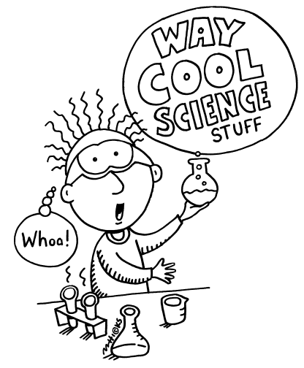
- Never eat, drink, chew gum, or taste anything in the science classroom unless specifically instructed by your teacher.
- Wash your hands with soap & water before leaving class.
- Wear safety goggles when instructed.
- Keep work area neat and free of unnecessary materials.
- Clean ALL work areas & equipment at the end of the experiment. Dispose of waste as instructed.
- Consider all chemicals used in the lab to be dangerous. Do NOT touch or smell any chemicals unless specifically told to do so.
- Handle all glassware with care. Never pick up broken or hot glassware with bare hands.
- Use extreme caution when using matches, burners, or hot plates. Only light burners when instructed and do not put anything into a flame unless specifically instructed by your teacher. NEVER leave a flame unattended.
- Dress properly-long hair must be tied back, no dangling sleeves or jewelry, wear closed toe and heeled shoes. Wear lab aprons as instructed.
- Learn where the safety equipment is and where the emergency exits are.
- REPORT ANY ACCIDENT IMMEDIATELY.

